NLP MINI PROJECT

Title of Mini Project: To Formulate and create AI Voice-Assistants for personized Fitness Training
Group Members of Mini Project:
1. Atharva Harane - 15
2. Darsh Kamble - 23
3. Altamash Chougle - 05

Theory:

Problem Statement:

Many individuals struggle with maintaining consistency and proper guidance in their fitness journey due to a lack of personal trainers, time constraints, or high costs of professional training. Existing fitness apps are either text-based or video-based, which limits real-time, interactive, and personalized support during workouts.

Concept:

The Fitness Training VAPI (Voice Assistance Personal Instructor) leverages AI-driven voice assistance to act as a virtual fitness coach. By integrating speech recognition, natural language processing (NLP), and personalized fitness plans, the system can guide users through exercises, monitor their performance (via sensors or manual inputs), and provide real-time feedback. This hands-free interaction makes workouts more engaging, safe, and accessible.

Features:

Voice Commands – Users can interact with the system hands-free, asking questions or requesting workout changes.

Personalized Training Plans – Customized routines based on user’s age, health data, goals, and fitness level.

Real-Time Feedback – Voice prompts for correcting form, tracking repetitions, and motivating users.

Progress Tracking – Keeps logs of workouts, calories burned, and improvements over time.

Multilingual Support – Helps reach a wider audience by supporting local and global languages.

Integration with Wearables – Sync with smartwatches and IoT devices for real-time data monitoring.

Tech Stack:

Component | Technology / Tool
Programming Language | Python
NLP Toolkit | spaCy / NLTK / Transformers (HuggingFace)
Speech Recognition | Google Speech Recognition API / Vosk
Backend | Flask / FastAPI (for server logic)
Frontend | HTML, CSS, JavaScript (for user interface)
ML Model | KNN / Rule-based logic for plan recommendations

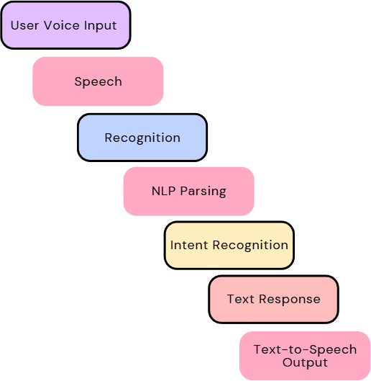
System Architecture (Flowchart):
Objective:
- Home Fitness & Wellness Apps: Users can get gym-like experience at home with customized plans.

Senior Citizen Assistance: Voice-based hands-free interaction helps elderly people engage in guided light workouts or therapy sessions.

Fitness for Visually Impaired Users: With audio-only interaction, blind users can benefit from exercise instruction.

Corporate Wellness Programs: Companies can implement it in their wellness offerings for employee health.

Rehabilitation Training: Patients recovering from injury/surgery can receive guided voice-based therapy sessions.

Applications:

Home Workouts – Individuals without access to gyms can train effectively with real-time assistance.

Rehabilitation – Patients recovering from injuries can follow safe, voice-guided physiotherapy exercises.

Sports Training – Athletes can use it for drills, warmups, and endurance monitoring.

Corporate Wellness Programs – Organizations can provide employees with fitness voice assistants to promote health.

Use Cases:

Beginner’s Fitness Guide – A user says, “Start a 15-minute cardio session”, and the assistant provides step-by-step voice instructions.

Form Correction – If a user’s wearable detects irregular movement, the assistant says, “Keep your back straight during squats”.

Motivation – Encouraging feedback like, “Great job! Only 2 reps left”.

Diet & Lifestyle Tips – Voice queries such as “What should I eat post-workout?” get instant, AI-driven recommendations.

Link Of Website: click here

Output:

1.1 Landing Page:
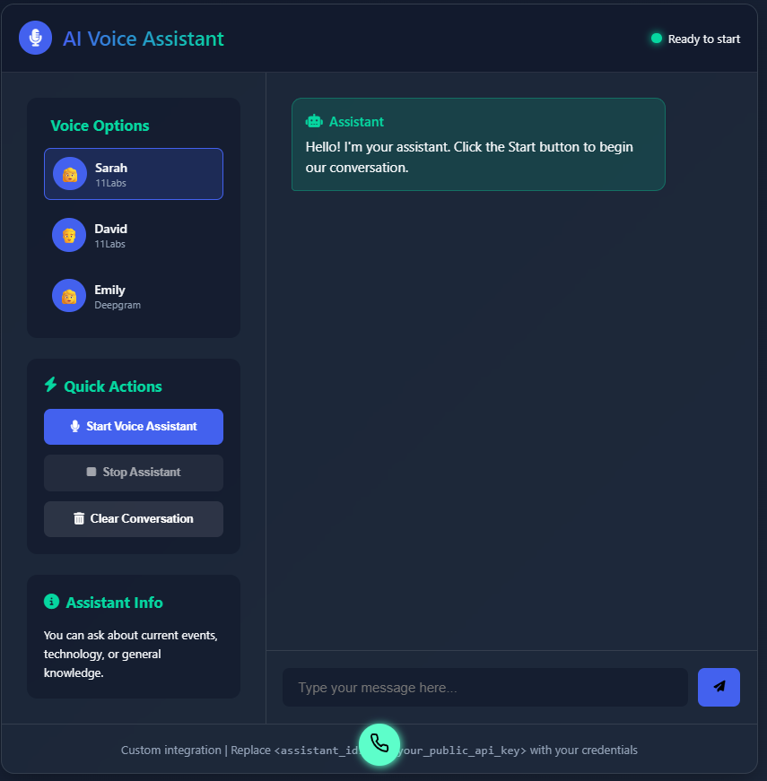

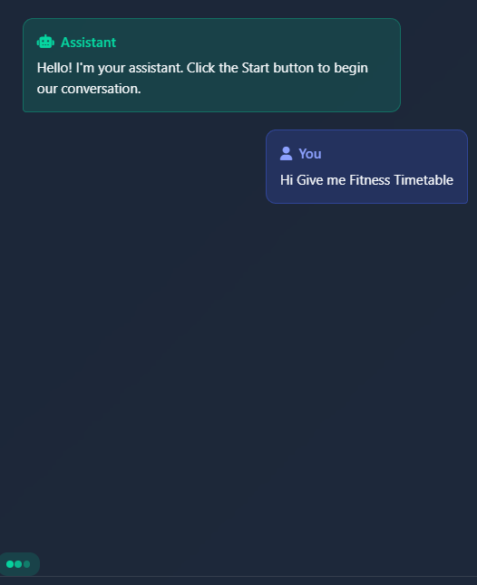
1.2 Chat with AI assistance:

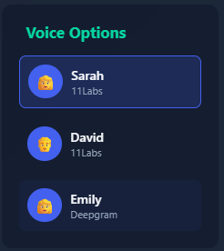
1.3 Different Voice Option based on Gender:

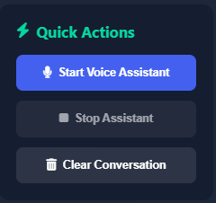
1.4 Quick Action to control AI assistance:

1.5 Chat with AI by enabling Microphone:
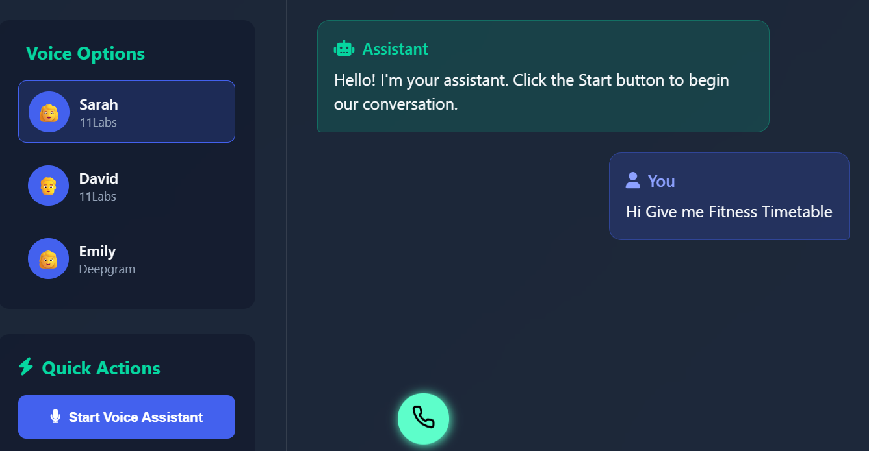

Conclusion:

The Fitness Training VAPI creates an affordable, interactive, and intelligent solution to bridge the gap between professional trainers and individuals seeking guidance. With AI-driven voice assistance, it transforms fitness into a personalized, engaging, and motivating experience. Future enhancements can include AR/VR workout guidance, advanced emotion detection, and gamification to maximize user engagement and health outcomes.

From a conceptual standpoint, the solution leverages Voice AI (VAPI) integrated with machine learning models to provide personalized workout recommendations, track progress, and adapt routines according to the user’s fitness goals. By combining speech recognition, natural language processing, and cloud-based data storage, the system creates an interactive training experience that feels like a one-on-one session with a real coach.

A strong use case scenario is for beginners who are intimidated by gyms. They can interact with the voice assistant, set their fitness goals, receive a personalized plan, and track progress without requiring direct human intervention. Another use case is for patients undergoing physiotherapy, where guided voice instructions can help them perform prescribed exercises correctly.

In conclusion, the Fitness Training VAPI stands as a transformative innovation in digital health and fitness, offering scalability, affordability, and personalization. With future upgrades like AR/VR-based immersive workouts, wearable device integration, and gamification features, it has the potential to redefine how people approach physical fitness, ensuring healthier lifestyles for a wider population.

